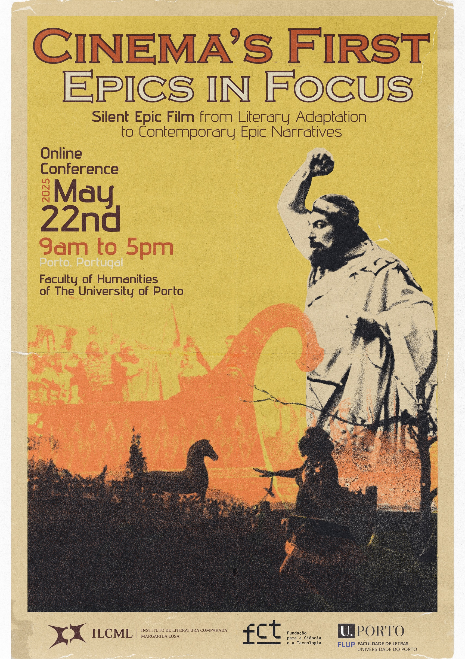

Cinema’s First Epics in Focus:
Silent Epic Film from Literary Adaptation to Contemporary Epic Narratives

Though epic cinema is most commonly associated with the mid-century triumphs of Hollywood, its origins extend far deeper into the history of the medium, reaching back to the earliest days of film, long before the advent of sound. The first documented uses of the term "epic" in relation to film stem from the nascent Italian industry, where monumental productions like L’Odissea (1911, dir. Francesco Bertolini, Giuseppe de Liguoro, Adolfo Padovan) not only astonished audiences with unprecedented scale but employed vast promotional efforts to assert a distinctly national—and as Maria Wyke and Pantelis Michelakis have noted, overtly nationalistic—cinematic identity. This movement towards epic during the silent era, often drawing inspiration from classical epic poetry and Christian narrative, has been understood to be important in the broader context of the nationalist fervor that swept through Europe in the years leading up to and following the First World War, yet has been curiously overlooked by film scholars, due in large part to the fragility of early film materials and inconsistent archival practices which have led to the loss of many key works. This neglect is particularly regrettable when we consider that the silent epic was central to the major artistic and ideological shifts that defined the early cinematic project, deeply enmeshed in the ontological debates over cinema’s status as a visual and rhythmic art—debates that were especially vibrant in early French and German cinema—and later in the drive toward realism that would come to dominate Hollywood, championed by academic figures such as André Bazin. The continued presence of the epic, from the silent era through to the sound era, underscores its fundamental role in cinema's dialogue with other arts as well as its longitudinal development, and in recognizing the centrality of early epics to the history of film, this conference seeks to reassert their study, not only as historical artifacts but as key contributions to an ever-evolving art of cinema.

Topics of interest include, but are not limited to:

• Representations of mythological, biblical, and historical themes in silent epic film;
• Adaptation and silent epic film;
• The influence of other arts on the silent epic film;
• The influence of the silent epic film on other arts;
• Impressionism, expressionism, theatricality and realism in silent epic film;
• Cinematic techniques and narrative in silent epic film;
• National cinema(s) and the politics of silent epic film;
• Gender, class, and ethnicity in silent epic film;
• Colonialism and silent epic film;
• Spectatorship and silent epic film;
• Scale and mise-en-scène in silent epic film;
• Modern cinema and silent epic film;
• Comparative studies of silent epic film;
• Lost silent epic film;
• Restorations and rediscoveries of silent epic film;
• Musical accompaniment and silent epic film.

Organizers:
Vítor Alves Silva (University of Porto)
João Paulo Guimarães (ILCML, University of Porto)
Larson Powell (Curators’ Distinguished Professor of Film – Emeritus – University of Missouri Kansas City)

Scientific Committee:
Marta Isabel Várzeas (Professora Auxiliar, University of Porto)

Conference Date:
May 22nd, 2025 (via Zoom for presenters, streamed on Facebook)
The deadline for submitting abstracts is March 31st, 2025.

There is no registration fee. We accept proposals in Portuguese, English, French or Spanish, but strongly encourage presenters to make available a translation of their work in English in case it is submitted in another language. For consideration, please submit an abstract of no more than 300 words indicating “CFP Silent Film” in the e-mail object, along with a brief author bio, to up202204445@up.pt, powelllar@umkc.edu and guimaraesjpc@gmail.com. Notifications of acceptance will be sent by April 1st, 2025.

For any questions or further details, please contact the organizers via the e-mails listed above.

